Name: Date: i-e words 2

The long (i) sound is most often represented using the i-e pattern when it comes in the middle of words, like in the words below.

Remember: Say the word aloud, then say each letter aloud as you write it e.g. 'five, f ... i ... v ... e'

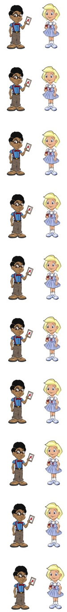
The number five is an odd number.

If something is live, it is not recorded and is happening now.

A prize is something that you can win.

A match can be used to start a fire.

If you hire something, you only take it for a while.

A price tells you how much something costs.

You can describe (de/scribe) using all of your senses.

To provide (pro/vide) something means to give it.

You can use a clock to tell the time.


The word climb is a naughty red word that belongs to Nina and Neil because it uses the letters imb to represent the long (i) sound.
To climb something means you go up it.
c[l[i[m[ø c[l[i[m[ø

Now test yourself without looking at the words and check for yourself if you got them all right. Practice writing any words that you made mistakes on again.

© www.SaveTeachersSundays.com 2013
Name: Date: i-e words 2

The long (i) sound is most often represented using the i-e pattern when it comes in the middle of words, like in the words below.

Remember: Say the word aloud, then say each letter aloud as you write it e.g. 'five, f ... i ... v ... e'

Try to spell each word without looking at it.

The number is an odd number.

If something is , it is not recorded and is happening now.

A is something that you can win.

A match can be used to start a .

If you something, you only take it for a while.

A tells you how much something costs.

You can using all of your senses.

To something means to give it.

You can use a clock to tell the .

To something means you go up it.

Now check for yourself if you got them all right. Practice writing any words that you made mistakes on again.

© www.SaveTeachersSundays.com 2013

